CHAPTER 4 MARKETING AND INVENTORY MANAGEMENT

4.1 Definition of Market,

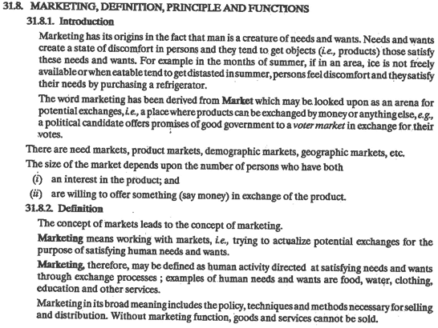

Functions of Marketing Department

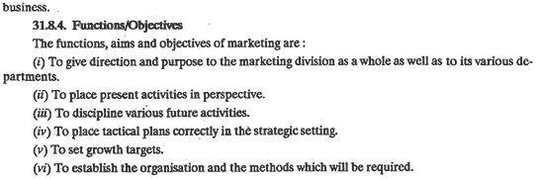

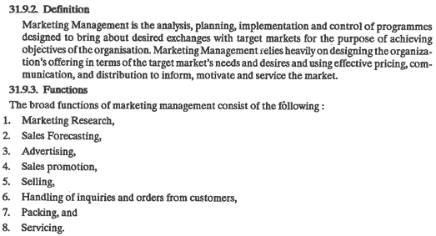

4.2 Marketing strategies

Marketing environment,

Consumer behavior,

Market research,

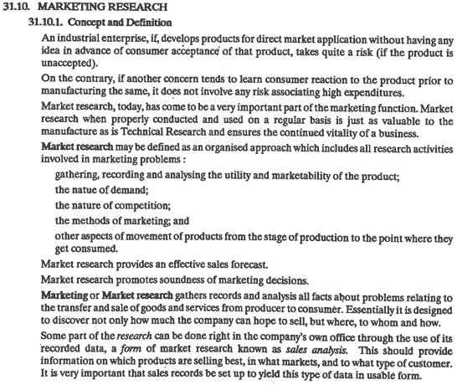

Market survey,

,

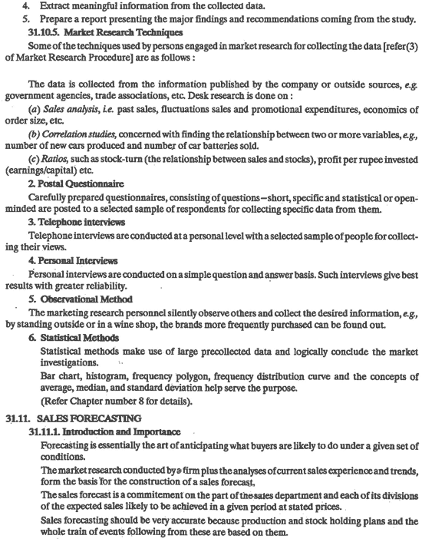

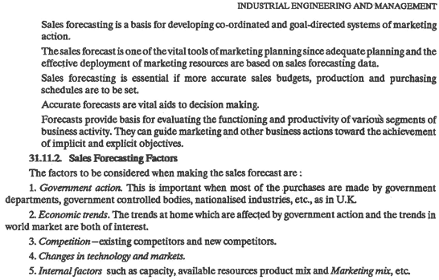



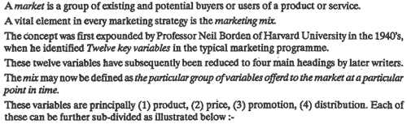

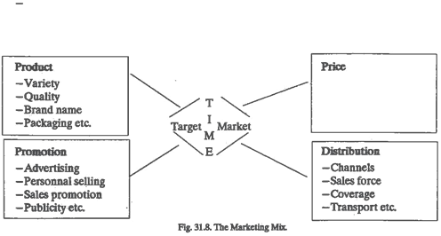

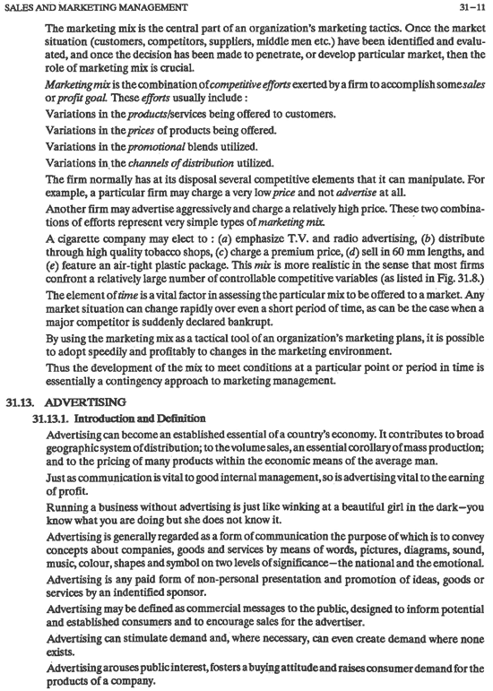

a)The press-newspaper, magazine, journal

b)commercial television

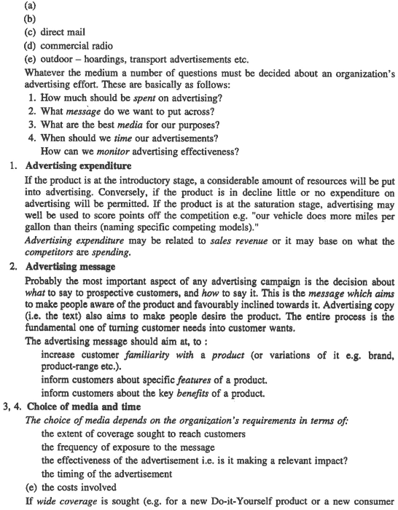

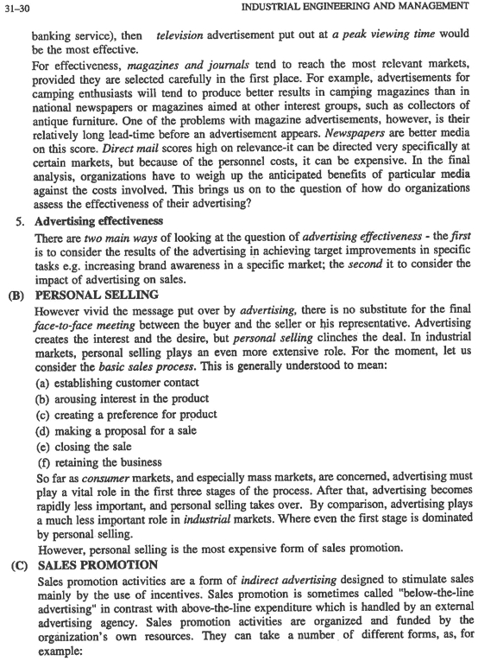

Sales promotion

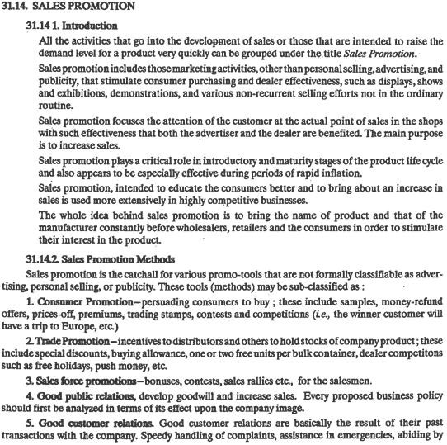

Sales promotion

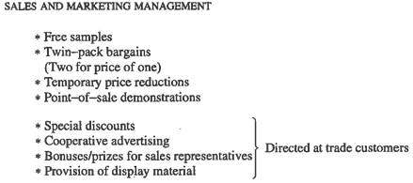

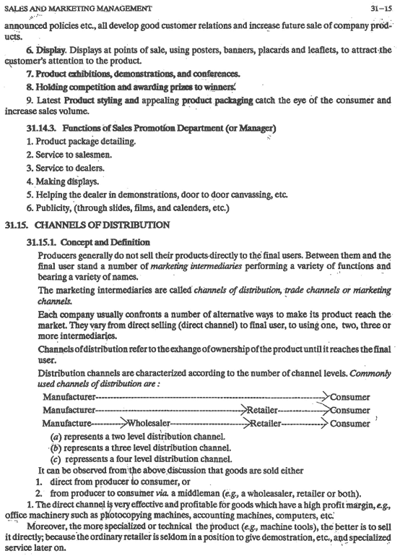

4.4 Definition of inventory &inventory control.



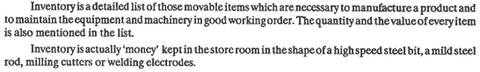

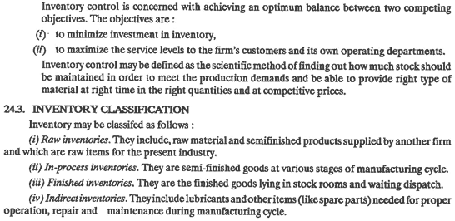

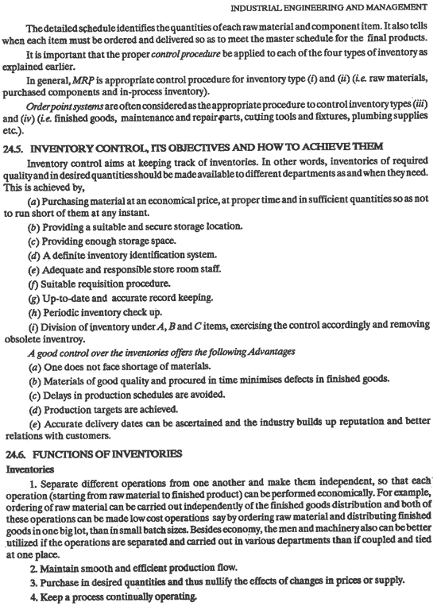

ABC analysis



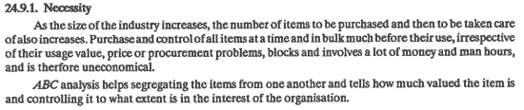

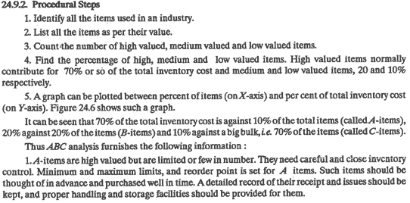

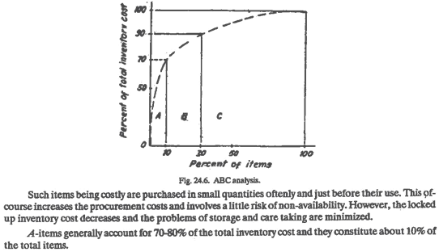

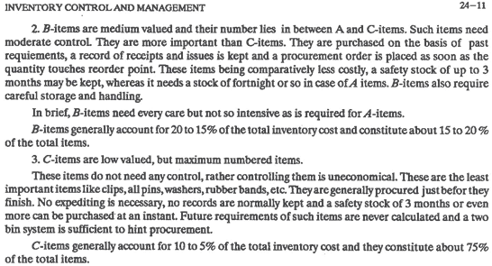

VED analysis

The degree of criticality can be stated as whether the material is vital to the process of production, or essential to the process of production or desirable for the process of production. • This classification is known as **VED analysis**, V stands for vital, E stands for essential and D stands for desirable items.

VED Analysis :- It attempts to classify the items used into three broad categories, namely Vital, Essential, and Desirable. The analysis classifies items on the basis of their criticality for the industry or company.

Vital: Vital category items are those items without which the production activities or any other activity of the company, would come to a halt, or at least be drastically affected.

Essential: Essential items are those items whose stock – out cost is very high for the company

Desirable: Desirable items are those items whose stock-out or shortage causes only a minor disruption for a short duration in the production schedule. The cost incurred is very nominal.

VED Analysis is very useful to categorize items of spare parts and components. In fact, in the inventory control of spare parts and components it is advisable, for the organization to use a combination of ABC and VED Analysis. Such control system would be found to be more effective and meaningful.